CEE 671 Finite Element Analysis Homework #2
Shibo Wang March 28, 2008

Analyze a clamped-clamped beam with a point-load in the center. Using the following properties: Young’s Modulus=100 GPa, Poisson’s Ratio=0.3, height=0.05m, and width=0.025m

2.1 Compare the effect of different element types (i.e. interpolation functions) by determining the minimum number of elements required to obtain results that are within 5% of the analytical solutions (for small deflections) for (a) two-node elements with linear interpolation, and (b) two-node elements with cubic interpolation. Repeat the analysis for three different beam lengths: L/h=5, L/h=25, and L/h=125.

Solution:

Property Parameter | E | v | h | w (b)
value | 100.E9 | 0.3 | 0.05 | 0.025

According to small deflection of 1-D beam
Moment of inertia 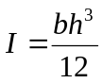 where 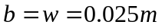 and 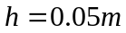
Therefore, 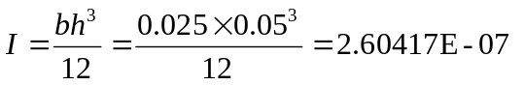m⁴
Displacement at the center point can be expressed by 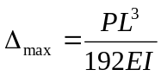. Prescribe a small deflection of 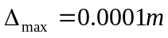for the three cases L/h=5, L/h=25, and L/h=125 respectively, then the analytical solution to the applied loads are listed below:
 | L/h=5 | L/h=25 | L/h=125
L (m) | 0.25 | 1.25 | 6.25
Load P | 4000 | 32 | 0.256
- for the L/h=5 case, elements of 2,4,6,8,10,50,100 are calculated respectively by using ABAQUS.
i. linear interpolation----TYPE=B21
# of elements | 2 | 4 | 6 | 8 | 10 | 50 | 100
Displacement  From ABAQUS(m) | 8.87E-05 | 1.06E-04 | 1.10E-04 | 1.11E-04 | 1.11E-04 | 1.12E-04 | 1.12E-04
Discrepancy(%) | 11.294 | 6.35 | 9.62 | 10.76 | 11.29 | 12.2 | 12.23
Based on the results in the above table, 5% error cannot be achieved by increasing the number of elements. In another word, the results diverge. This could be explained that since the ratio of L/h is relatively small, the beam cannot be considered as a Bernulli-Euler beam. It should be a Timoshenko-Mindlin beam, which may introduce shear stress to affect the displacements.
ii. Cubic interpolation----TYPE=B23
# of elements | 2 | 4 | 6 | 8 | 10 | 50 | 100
Displacement  From ABAQUS(m) | 1.00E-04 | 1.00E-04 | 1.00E-04 | 1.00E-04 | 1.00E-04 | 1.00E-04 | 1.00E-04
Discrepancy(%) | 0 | 0 | 0 | 0 | 0 | 0 | 0
It is shown by the results that even using 2 elements, the simulation can be exact as the
analytical solutions. This can be explained that since the formula for small deflection follows a cubic shape, the results obtained from cubic interpolation should then be the same as the analytical solution.
- for the L/h=25 case, elements of 2,4,6,8,10,50,100 are applied respectively by using ABAQUS.
i. linear interpolation----TYPE=B21
# of elements | 2 | 4 | 6 | 8 | 10 | 50 | 100
Displacement  From ABAQUS(m) | 7.70E-05 | 9.46E-05 | 9.79E-05 | 9.90E-05 | 9.95E-05 | 1.00E-04 | 1.00E-04
Discrepancy(%) | 23.04 | 5.393 | 2.125 | 0.981 | 0.452 | 0.45 | 0.48
Compared with L/h=5, the results obtained here converge. The minimum number required to of elements achieving less-than 5% error is 4. Since the ratio of L/h is much bigger than the last one, this beam should be a Bernulli-Euler beam. No shear happens to the planes. Assuming small deflection is valid.
ii. Cubic interpolation----TYPE=B23
# of elements | 2 | 4 | 6 | 8 | 10 | 50 | 100
Displacement  From ABAQUS(m) | 1.00E-04 | 1.00E-04 | 1.00E-04 | 1.00E-04 | 1.00E-04 | 1.00E-04 | 1.00E-04
Discrepancy(%) | 0 | 0 | 0 | 0 | 0 | 0 | 0
The reason why there is no error is the same as the last one.
- for the L/h=125 case, elements of 2,4,6,8,10,50,100 are applied respectively by using ABAQUS.
i. linear interpolation----TYPE=B21
# of elements | 2 | 4 | 6 | 8 | 10 | 50 | 100
Displacement  From ABAQUS(m) | 7.65E-05 | 9.41E-05 | 9.74E-05 | 9.85E-05 | 9.91E-05 | 1.00E-04 | 1.00E-04
Discrepancy(%) | 23.51 | 5.863 | 2.595 | 1.451 | 0.922 | 0.018 | 0.01
In this case, the results also converge with increasing elements. 4 elements is expected to achieve a lower-than 5% discrepancy.
ii. Cubic interpolation----TYPE=B23
# of elements | 2 | 4 | 6 | 8 | 10 | 50 | 100
Displacement  From ABAQUS(m) | 1.00E-04 | 1.00E-04 | 1.00E-04 | 1.00E-04 | 1.00E-04 | 1.00E-04 | 1.00E-04
Discrepancy(%) | 0 | 0 | 0 | 0 | 0 | 0 | 0

2.2 Illustrate the effect of large deflections by determining the load-point displacement at which the corresponding load (to achieve that displacement) is 25% from the analytical solutions for small deflections. Demonstrate the effects of mesh density by plotting the critical load-point displacement (at which the linear solution is no longer accurate) versus element size. Repeat the for two different beam lengths: L/h=25, and L/h=125.

Solution:

Property Parameter | E | v | h | w (b)
value | 100.E9 | 0.3 | 0.05 | 0.025

According to small deflection of 1-D beam
Moment of inertia where and
Therefore,
According to small deflection, since displacement at the center point , therefore, load at the central point should be 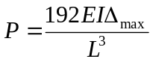. Prescribe several displacement (including both small and large ones) to find the critical load-point at which the small-deflection assumption is not valid (i.e. beyond 25% discrepancy). The length L is obtained under both L/h=25 and L/h=125 scenarios.

Analysis # | L/h=25 | L/h=125
L (m) | 1.25 | 6.25

(a).for the L/h=25 case, displacements of 0.01, 0.015, 0.02, 0.022,0.023, 0.0232, 0.0235, 0.024, 0.025 and 0.028m are simulated respectively by running ABAQUS using two elements.
Cubic interpolation----TYPE=B23
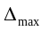 | 0.01 | 0.015 | 0.02 | 0.022 | 0.023 | 0.0232 | 0.0235 | 0.024 | 0.025 | 0.028
P from analytical solution | 3.20E+03 | 4.80E+03 | 6.40E+03 | 7.04E+03 | 7.36E+03 | 7.42E+03 | 7.52E+03 | 7.68E+03 | 8.00E+03 | 8.96E+03
P from ABAQUS | 3348 | 5301 | 7588 | 8621 | 9166 | 9278 | 9447 | 9732 | 1.03E+04 | 1.22E+04
error | 4.62 | 10.4 | 18.6 | 22.5 | 24.5 | 25.0 | 25.6 | 26.7 | 29.0 | 36.4
The critical load-point displacement should be 0.0232m.
Apply 4, 6, 8, 10, 30, 50 and 100 elements to demonstrate the effect of mesh density on critical load-point displacement. The critical points are found as below:
Elements # | 4 | 6 | 8 | 10 | 30 | 50 | 100
Critical Load-Points | 0.0295 | 0.0296 | 0.02957 | 0.02957 | 0.0296 | 0.02965 | 0.02972
P from ABAQUS | 11804 | 11841 | 11829 | 11832 | 11843 | 11862 | 11884
Plot the load-point displacement versus mesh density as below:
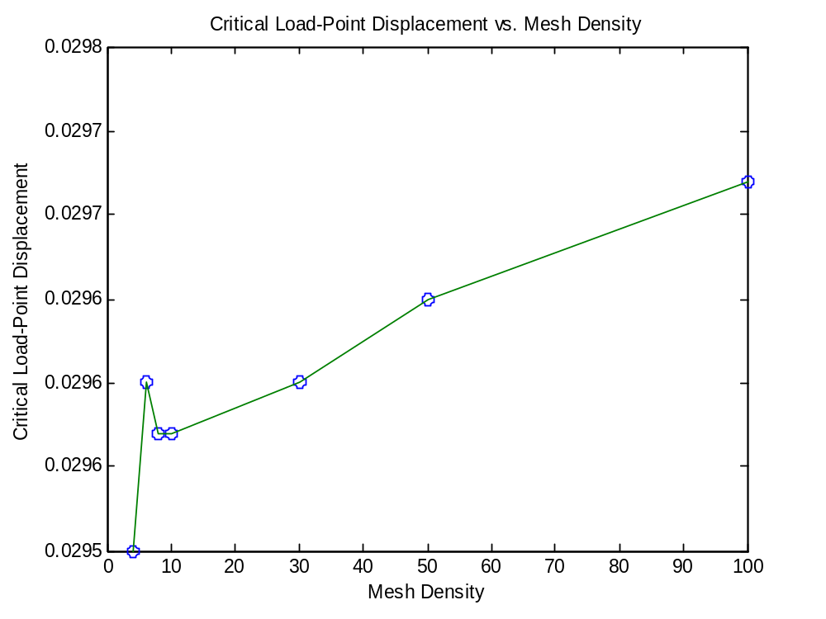
From the plot, it can be seen that with increasing elements, the critical points converge to a constant value. The differences between the results are as small as 10⁻⁵ m. Therefore, the accuracy is improved when elements are adding.
(b).for the L/h=125 case, displacements of 0.015, 0.018, 0.02, 0.022, 0.023, 0.0232, 0.0235, 0.024, 0.030m are simulated respectively by running ABAQUS using two elements.
Cubic interpolation----TYPE=B23
 | 0.015 | 0.018 | 0.02 | 0.022 | 0.023 | 0.0232 | 0.0235 | 0.024 | 0.030
P from analytical solution | 3.84E+01 | 4.61E+01 | 5.12E+01 | 5.63E+01 | 5.89E+01 | 5.94E+01 | 6.02E+01 | 6.14E+01 | 7.68E+01
P from ABAQUS | 42.41 | 53.01 | 60.71 | 68.98 | 73.34 | 74.24 | 75.59 | 77.87 | 108.9
error | 10.4 | 15.0 | 18.6 | 22.5 | 24.6 | 25.0 | 25.6 | 26.7 | 41.8
The critical load-point displacement is found to be 0.0232m.
Apply 4, 6, 8, 10, 30, 50 and 100 elements to demonstrate the effect of mesh density on critical load-point displacement. The critical points are found as below:
Elements # | 4 | 6 | 8 | 10 | 30 | 50 | 100
Critical Load-Points | 0.0295 | 0.02965 | 0.0296 | 0.0296 | 0.0296 | 0.02962 | 0.02965
P from ABAQUS | 94.38 | 94.90 | 94.72 | 94.75 | 94.73 | 94.79 | 94.89
Plot the load-point displacement versus mesh density as below:
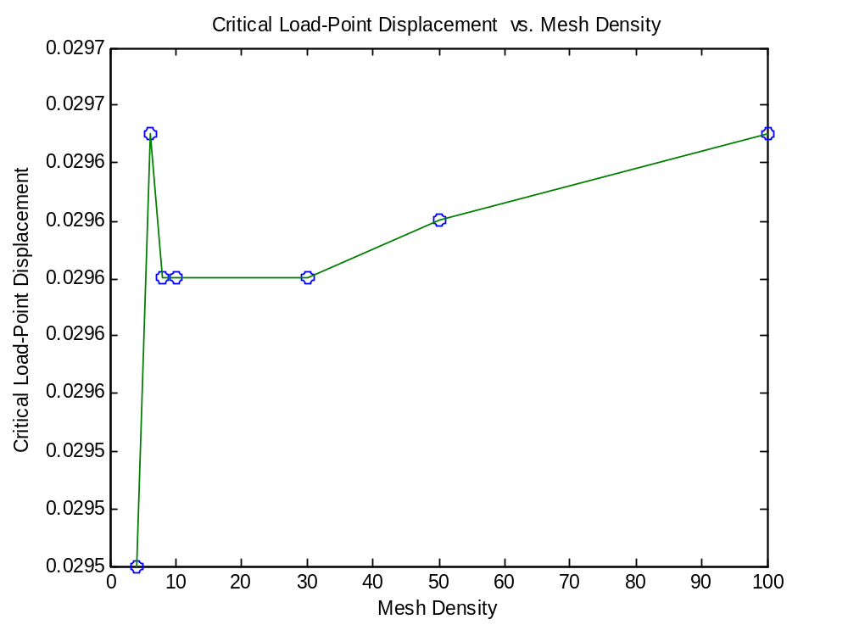
From the plot results, better accuracy is achieved with more elements.

2.3 Illustrate the effect of pre-tension in the beam by prescribing a temperature change to the beam: show that the effect of pre-tension is consistent the analytical solution for a pre-stressed beam. The solution in the first paper is an asymptotic expansion for small displacements derived from full solution for a point-loaded beam, described in the second paper.

Solution:
Based on the relationship between load and displacement under different thermal treatment temperature which is shown in Gaskins et al. paper, it can be concluded that the bigger temperature change is, the more stiff the beam.
4 elements have been used and the relationship between temperature change and applied loads is discussed separately for L/h=25 and L/h=125 scenarios.
(a). for the L/h=25 case, corresponding stresses under a certain displacement of 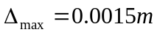 for different temperature change are investigated by running ABAQUS.
Cubic interpolation----TYPE=B23, initial temperature=200°C
Temp Change | -10 | -20 | -40 | -60 | -80 | -100 | -150 | -200
Stress | 523.5 | 566.6 | 652.8 | 738.8 | 824.7 | 910.4 | 1124.0 | 1337.0
Plot stresses versus temperature change
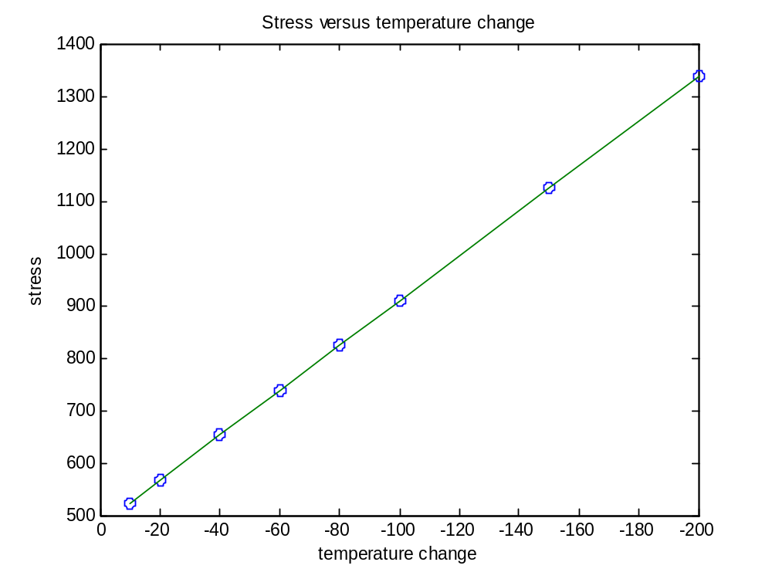
(b). for the L/h=125 case, corresponding stresses under a certain displacement of for different temperature change are investigated by running ABAQUS.
Cubic interpolation----TYPE=B23, initial temperature=200°C
Temp Change | -10 | -20 | -40 | -60 | -80 | -100 | -150 | -200
Stress | 12.40 | 20.83 | 37.48 | 53.97 | 70.37 | 86.72 | 127.5 | 168.1
Plot stresses versus temperature change
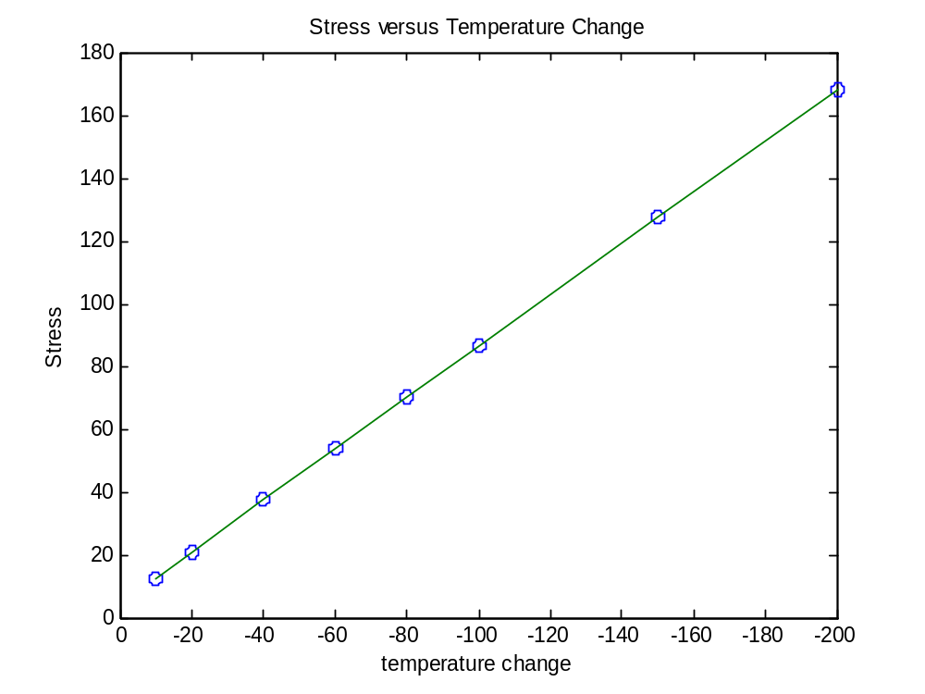
Compared with the results in the first paper, the results here are consistent with those, showing similar effects of pre-tension on the beam property.

